**12-18 notes**

Functional Programming for Data Processing

Goals:

* Apply the map() method and filter to parse data.
* Create and use arrow functions to simplify code.
* Use the filter() and arrow functions to manipulate and filter datasets.
* Use ES6 JavaScript methods.

**map() method:**

A method that creates a new array containing the results of calling a function for every element array.

Calls the provided function in order, once for each element in an array.

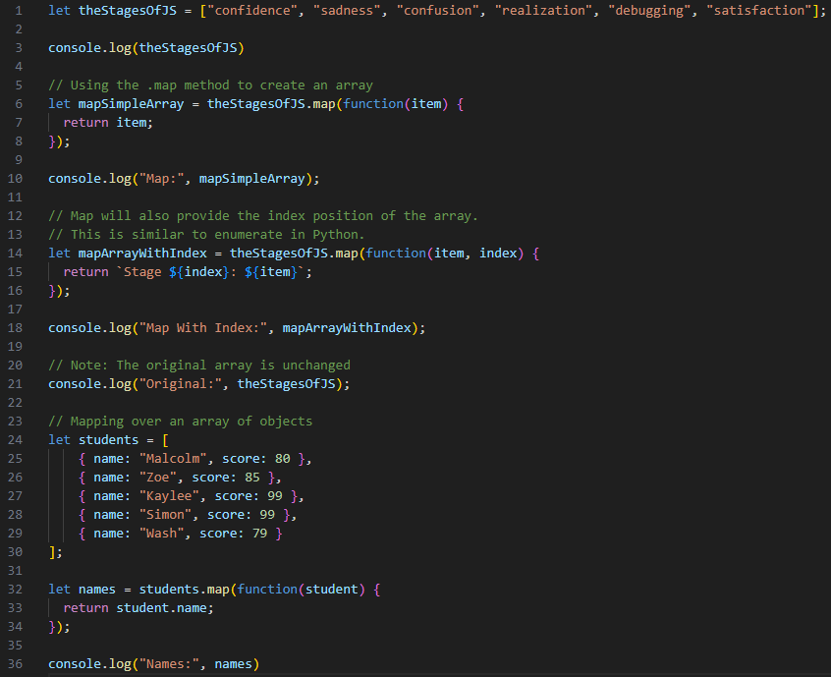

Results:

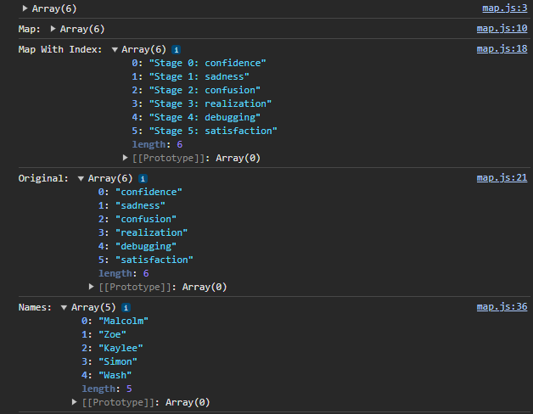

**Arrow Functions:**

The arrow function is an alternate way to write functions in JavaScript.

It was introduced in ES6 and allows us to write shorter functions syntax.

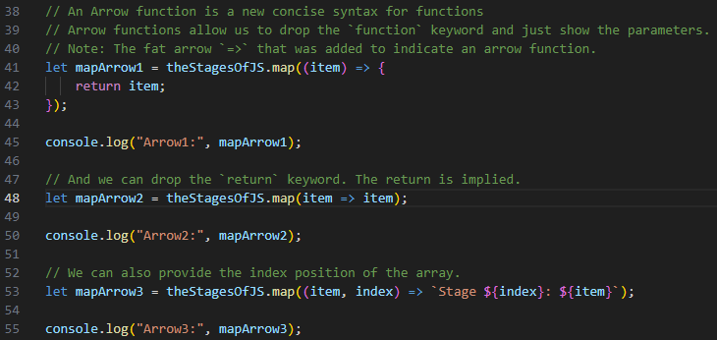

^ Lines 41-45 are explaining what’s going in. Lines 48-50 are the way to use most often

^ Line 53 has the backtick character ( ` ) from the bottom of the tilde ~ key.

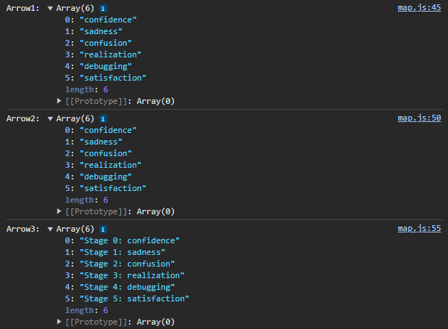

**Student Mapping Solution:**

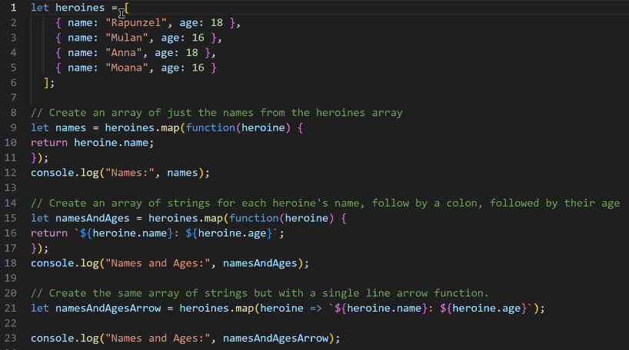

**Greek Gods Mapping with and graphing with Plotly Solution**

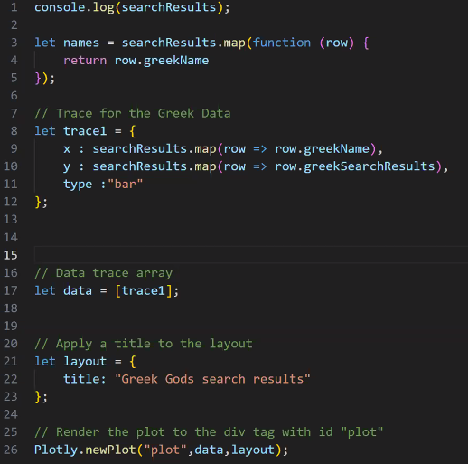

The filter() method creates an array with elements that pass a test provided as a function.

**Stu Filtering Solution:**

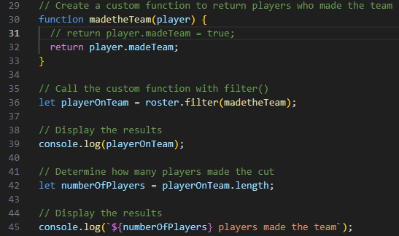

**Popular Roman Gods Solution:**

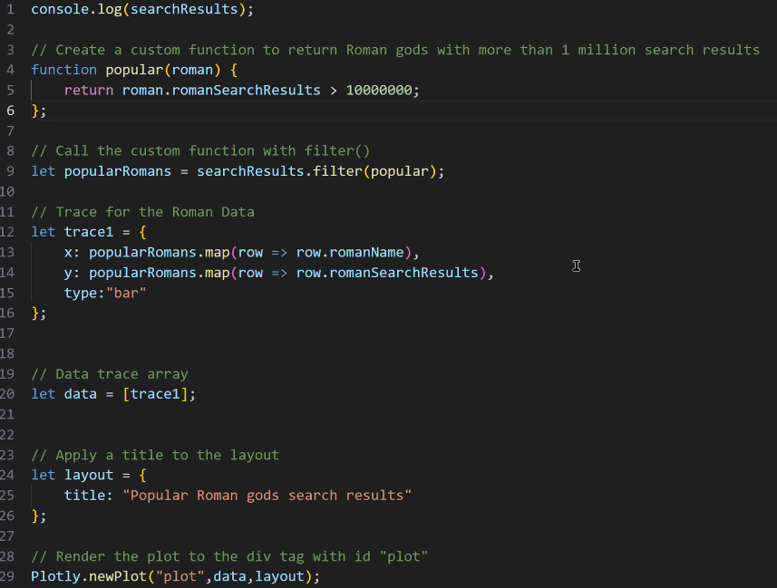

**Slicing:**

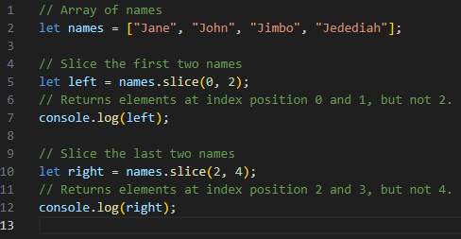

^ Line 5 returns the first two names, and line 10 returns the second two.

**Sorting:**

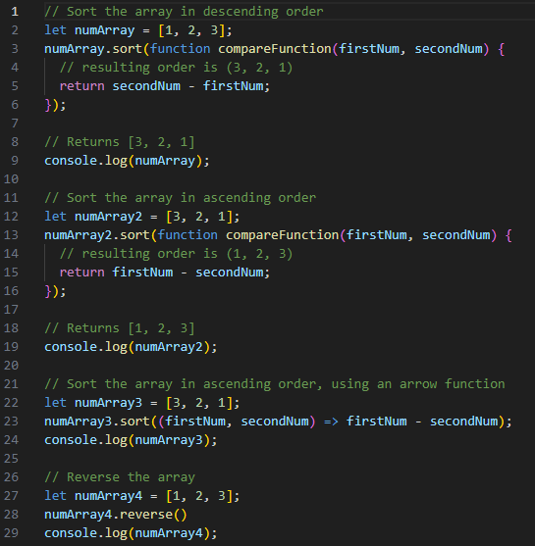

If compare function returns a positive number, it’ll keep the order

If compare function returns a negative number, it’ll reverse the order

Stu Sort and Slice solution:

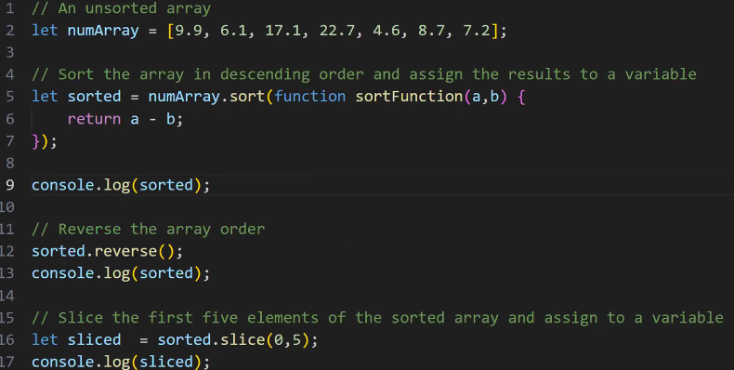

^ line 13- using  works, though it does the sorting in the wrong spot somehow (recording- 8:50pm-ish).

<https://www.w3schools.com/jsref/jsref_sort.asp> :

sort() sorts the elements of an array.

sort() overwrites the original array.

sort() sorts the elements as strings in alphabetical and ascending order.

**Stu Top 10 Greek Gods Solution:**

